**Vanier College**

**Faculty of Science and Technology**

**System Development 420-436-VA**

Deliverable 05

**Grey Team**

Gennaro Finelli

Mohammed Hosein Ali

Alexandre Pham

Wayne De Leon

In collaboration with CyberStation

**(Code from our eCommerce class will be used for certain features of this project)**

**We, the Grey Team, certify that this assignment is our own work**

I, Gennaro Finelli, student ID# 2268107, certify that I have contributed to this deliverable, G.F

I, Mohammed Hosein Ali, student ID# 2055295, certify that I have contributed to this deliverable, M.H.A

I, Alexandre Pham, student ID# 2048017, certify that I have contributed to this deliverable, A.P

I, Wayne De Leon, student ID# 2179710, certify that I have contributed to this deliverable, W.D

Table of Contents

Executive Overview 3

Client/Business 4

Business Domain 4

Business Environment 4

Description of Client 4

Business Problem 4

Narrative Description 5

Appendix 1 6

Appendix 2 7

Appendix 3 8

Appendix 4 11

Appendix 5 12

References 13

Project Plan 14

# Executive Overview

Cyber Station is a gaming lounge that provides its customers with the opportunity to play video games, while being able to be served food and drinks to enhance the experience. It combines the ideas of an arcade with the latest consoles. Cyber Station has a great business environment but can be further developed with an added online presence. Cyber Station has some current advertising through Instagram, and other websites that review Cyber Station, however they don’t have a website of their own. The staff is very friendly, and the business has great reviews. Our website will help the client and her staff with the organization of their reservations.

In this deliverable, we had to create a flowchart, a use uml cases diagram, a sequence diagram and a uml class diagram.

We mostly use draw.io to create these. We contacted the client through our main contact Mohammed, and every question we had goes through him. We were able to verify what she wants and her objectives for the website.

Deliverable 4 is a compilation of all our diagrams that acts as our model for the project, this deliverable helps us get an insight of the whole project and how the website will work in front and back matter. It’s also our map if ever we get lost on what goals are for the website, and what class we must use and do for the project.

# Business Problem

## Business Problem

Our client has no website for her gaming café business. So, she would like for us to make her a web application so clients can have an overview of her business. In the website, clients will be able to make reservations because clients usually line up in front of the store and don’t know the estimate of when they’ll be able to reserve spot. Additionally, they can also read up more about the business. Also, employees will be able to track reservations and CRUD their status’.

Lastly, the client writes all of her gross sales and cash profit with pen and paper. For that reason, she would like an additional feature to track sales (sales tracker).

# Narrative Description

In our system, there are four key actors: the Admin, User, Payment System, and the System itself. Each actor plays a distinct role in managing the core functionalities of the platform. These roles differ in terms of their responsibilities. The Admin is the owner of the gaming café. They have full access to all data and operational functions. They have for task to manage the stations, reservations, and payments. On the other hand, the User is the customer or client interacting with the reservation system. They are able to make a reservation, as well as the payment. Unlike the Admin, a user’s access is limited solely to their own data. They cannot view or modify other users’ reservation, nor can they access sensitive system data like payment records for other users. If they want to modify their reservation, then they will need to contact the gaming café. As for the Payment System, once the payment is confirmed via the API, then will make an automatic query request to the database to insert the information needed inside the Payment table. Lastly, the System is responsible for ensuring that users have the correct level of access based on their role, validating their input, and enforcing the rules and security protocols that maintain the integrity of the data. It does data validation, ensuring that only valid information is entered into the system, and it logs actions for security and audit purposes. This helps maintain the overall functionality and security of the platform, making sure that no unauthorized actions are performed, and that the data remains accurate and protected.

# Appendix 1

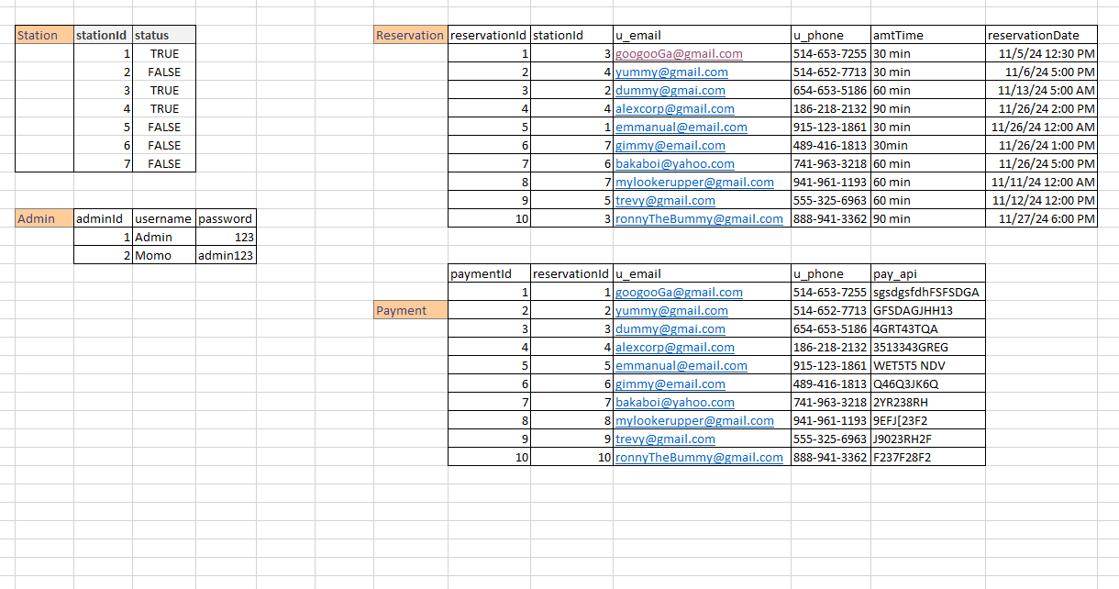

# Appendix 2

ER Diagram:  
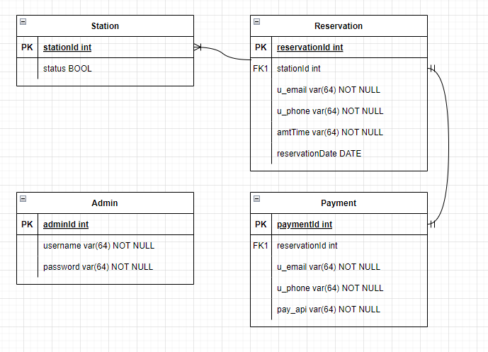

Reproduced Class UML Diagram:  
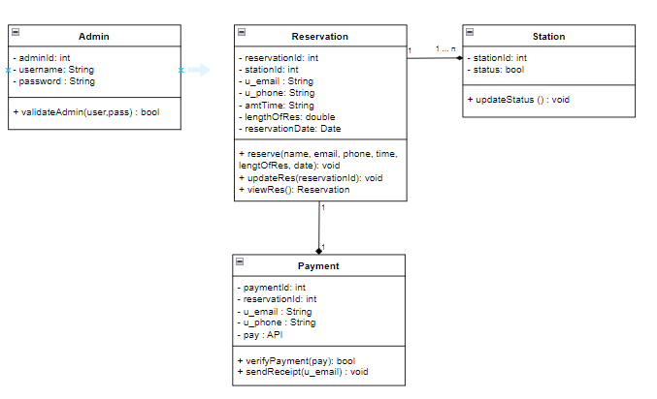

This Database ER Diagram is both similar to, and different, to the Class UML Diagram because they are both used to model systems. The purpose of the ER Diagram was to model the primary data of the database, specifically, to map out its entities, attributes, and the relationships between them. On the other hand, the purpose of the class UML diagram is to be used in OOP design.

# Appendix 3

To optimize the database, indexing is one of the most effective ways to do so by speeding it up. So, for our FKs, stationId (Reservation table) and reservationId (Payment table) will be used for indexing as they are frequently used for lookups and joins. PKs are already automatically indexed. Finally, the queries will be optimized.

1NF:

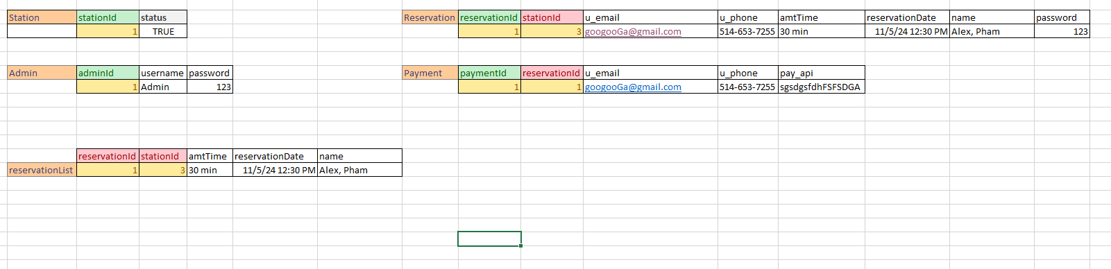

2NF:



3NF:

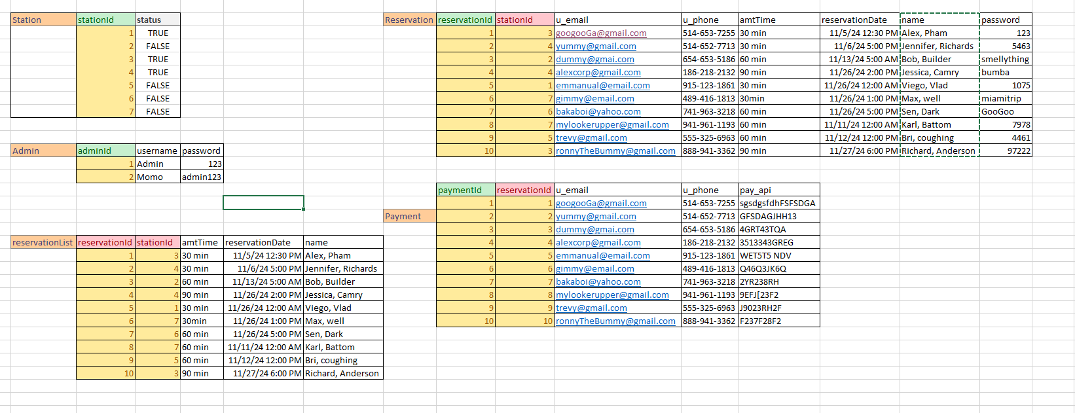

# Appendix 4

The database is used by the users and the admin upon request, whether the case is loading and scrolling through pages in the web application, booking and confirming reservations for the users, or logging in, and selecting, viewing, and deleting reservations for the admin and all other functionalities. The web application does not require much access speed due to it having less databases than most websites. Our design and code are not overly complicated because of the simple database that we have, and our scripts follow the standard protocol. For the users, making a reservation is the most time a user will access the database, and for the admin, logging in, loading, searching, editing and deleting reservations is the time the admin will request data. A single second or two is enough response time for these functionalities.

References

Hefner, T. (2022, May 3). *What is a gaming lounge?*. Join It. <https://joinit.com/blog/what-is-a-gaming-lounge#:~:text=It%20can%20also%20include%20tournaments,of%20a%20hang-out%20hub>.

# Project Plan

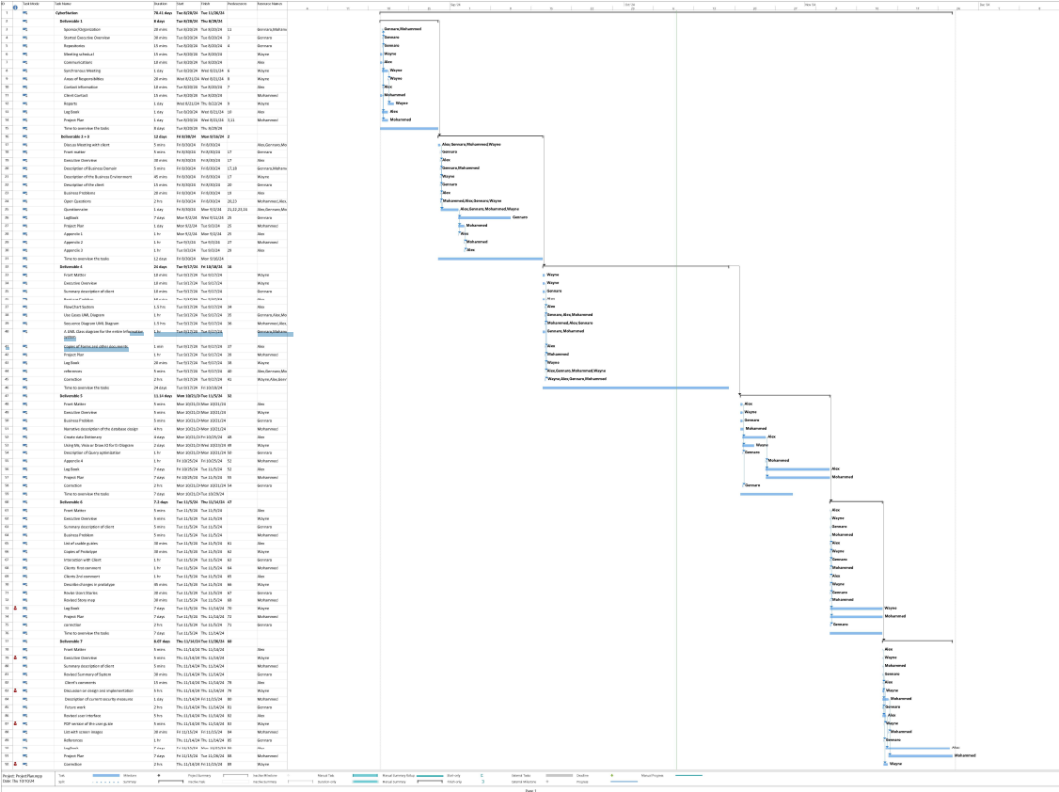

<https://drive.google.com/file/d/1lUXIBViiMUiIObikGKd2LoDrTmwTTGGx/view?usp=drive_link>